**ASG Project 8 – OLED Display**

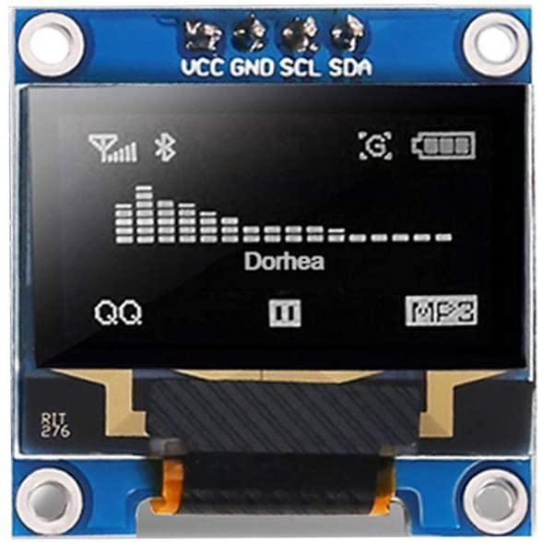The OLED Display uses a 2-wire serial bus call I2C (or I2C). This bus has a data line (SDA) and a clock line (SCL). You can see these on the picture of the OLED below. This project also introduces the concept of libraries which makes the Arduino SO powerful.

One the Arduino Nano SDA is on pin A4 and SCL is on pin A5. The display also has ground (GND) and 5V in (VCC).

To use the display you need to load the Adafruit libraries

* Adafruit SSD1306
* Adafruit GFX

These allow you to display text and graphics on this 128 x 64 pixel display.

You need to install these libraries using the library manager.

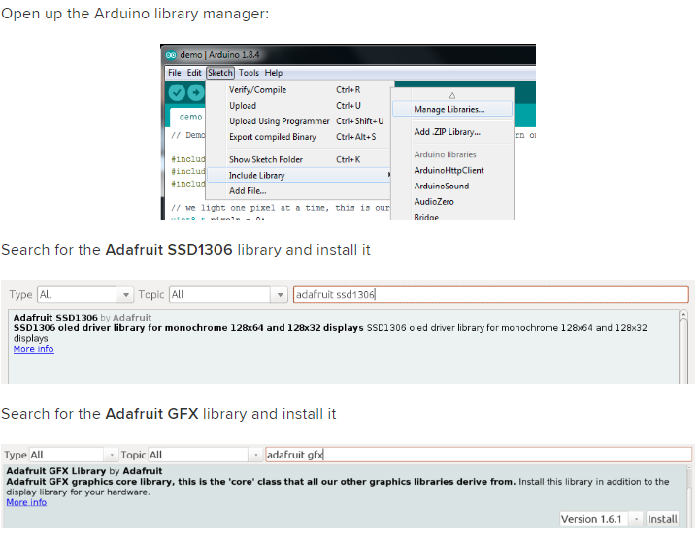

After you install the libraries, you will need to restart the Arduino IDE to get the examples to show up.

Now wire the board as shown below CONCEPTUALLY. The display device in Fritzing has different pins. Grr. **Make sure you wire up 5V, GND, SDA and SCL to the pin shown in the picture above.**

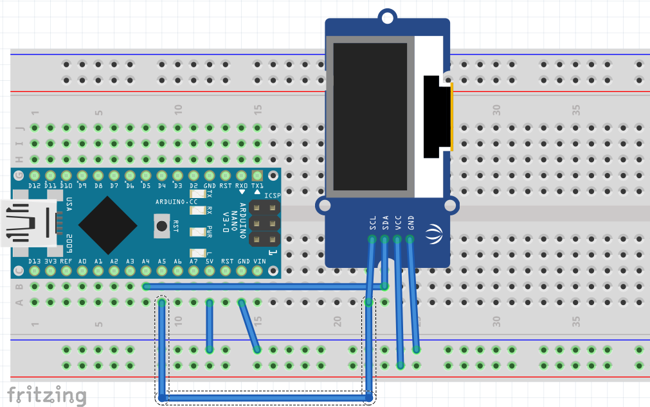

Now we are going to use the example code that comes with the libraries. Access the examples as shown below. You will have to scroll down in the Examples to see the Adafruit examples. Select “**ssd1306_128x64**” for the 128 x 64 pixel display. You can see this below.

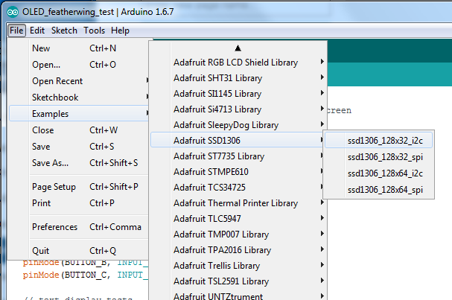

Almost there! In the setup() code, you need to give it the proper address.

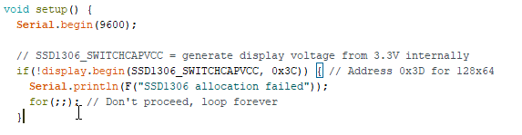

The default example code specifies 0x3D as the “address” of the device. These devices use address **0x3C** instead. Disregard the addresses on the back of the display. They don’t work.

What is the address? Each device on the I2C bus has a unique hexadecimal address up to 0xFF. When you communicate with it, part of the packet that goes out is the address, and only the device with that address will talk back. Yes, this has problems when you have two devices with the same address. Often you can change the device to a different address, or use a “multiplexer”. For now just use 0x3C.

Now, upload the code and watch the amazing tricks in the demo code. Cool, eh?

Next we want to just write text to the display. You will need the setup code shown above and some header information above the setup code. Create a new sketch and copy stuff in from the example.

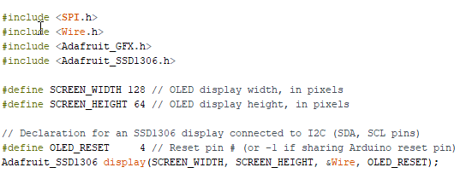

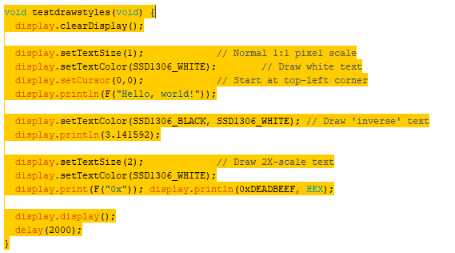Again, you can just copy this out of the example. To write text, look at the example code for “testdrawstyles”.

Try writing different messages to the display. Also try making other interesting graphics displays.